# [Date Squad] Site Plan

## [Tanner Brown]

## WDD 130

## Overview

### Purpose

[Our purpose is to raise funds for group dates]

### Audience

[We are looking for generous entrepreneurs that recognize the need to invest in the couples of the future]

## Branding

### Website Logo

## Style Guide

### Color Palette

|  |  |  |  |
| --- | --- | --- | --- |
| **Primary** | **Secondary** | **Accent 1** | **Accent 2** |
| #EF767A | #456990 | #EEB868 | #49BEAA |

### Typography

#### Heading Font: [Georgia]

#### Paragraph Font: [Tahoma]

### Navigation

Home Page2[sign up] Page3[date ideas]

**Content**

[put all content for the pages here, including written text and images]

**Group dates and socializing play a vital role in building meaningful connections and enhancing well-being. Group dates offer a relaxed, low-pressure environment where people can get to know each other naturally, making it easier to reveal true personalities and social dynamics. They provide safety, fun, and opportunities to form both romantic relationships and friendships, expanding social circles in a comfortable setting.**

**College students often face financial challenges when it comes to dating due to limited budgets and competing priorities. Many are juggling tuition fees, rent, textbooks, and daily living expenses, leaving little disposable income for social activities. Since dating often involves costs like meals, movies, or events, these expenses can quickly add up and feel burdensome.**

**Additionally, many students work part-time or rely on financial aid, which may not provide consistent or sufficient income. This unpredictability makes it hard to plan dates or commit to expensive outings. Peer pressure and social expectations to “keep up” with dating trends can also add stress, making students feel like they need to spend more than they can afford to fit in or impress.**

**Please Consider donating to help these College students have the fun they deserve.**

**Play Cupid [button]**

**Start A Date**

**©Tanner Brown**



**Date ideas (• Picnic in the Park**

**• Game Night (board games or card games)**

**• Potluck Dinner (everyone brings a dish)**

**• Movie Marathon at Home**

**• Hiking or Nature Walk**

**• Beach Day or Lake Outing**

**• Trivia Night at a Local Café or Bar**

**• Visit a Free Museum or Art Gallery**

**• Bowling (look for discount nights)**

**• DIY Craft Night**

**• Cooking or Baking Together**

**• Bike Ride Around Town**

**• Karaoke at Home or Local Open Mic**

**• Stargazing with Blankets**

**• Visit a Farmers Market and Sample Food**

**• Volunteering Together for a Cause**

**• Photo Scavenger Hunt Around the City**

**• Visit a Community Event or Festival**

**• Mini Golf (discount days or coupons)**

**• Visit a Public Garden or Botanical Park**

**• Escape Room at Home (DIY puzzles or online escape games)**

**• Frisbee or Catch in the Park**

**• Attend a Free Outdoor Concert or Movie**

**• Ice Cream Social (make sundaes at home)**

**• Visit a Local Bookstore or Library**

**• Take a Group Yoga or Fitness Class (many offer free trials)**

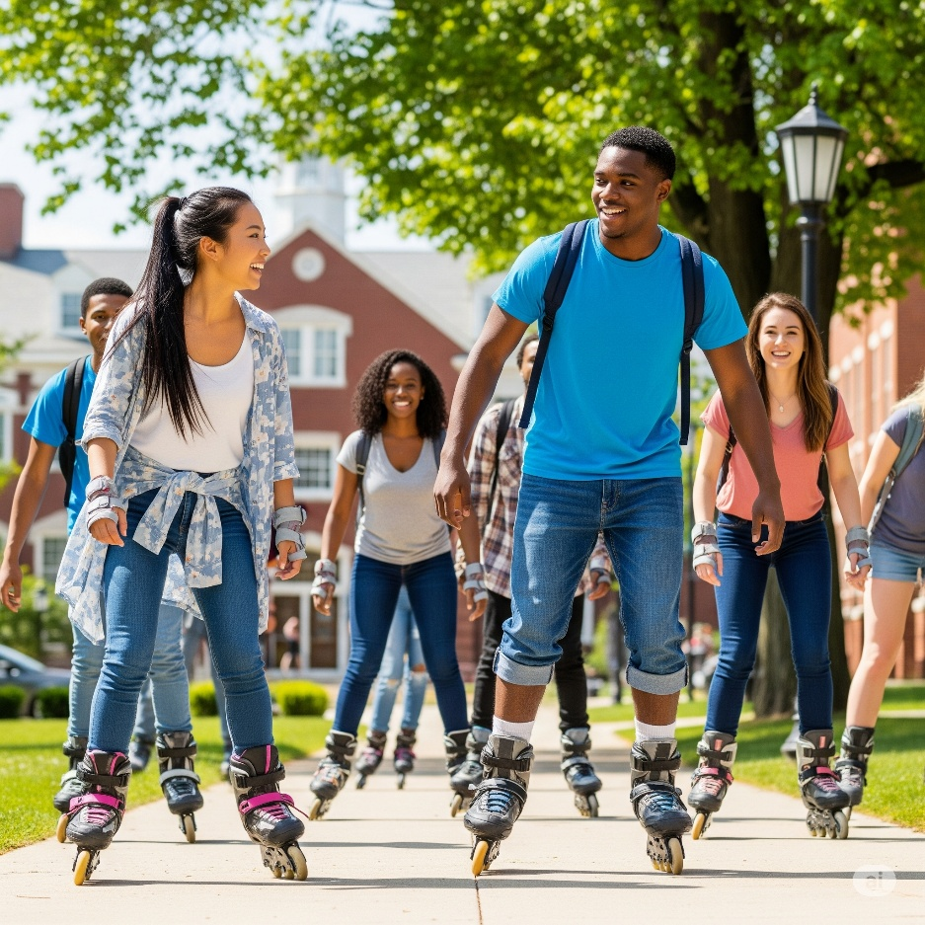**• Go Fruit Picking (seasonal and often inexpensive)**

**• Visit a Pet Shelter and Play with Animals**

**• DIY Pizza Night (everyone adds their own toppings)**

**• Watch a Sunrise or Sunset Together**

**• Attend a Community Sports Game (local league games are often cheap)**

**• Explore a New Neighborhood on Foot**

**• Make a Group Playlist and Have a Dance Party**

**• Write and Share Stories or Poems**

**• Play Video Games Together (local multiplayer or free online games)**

**• Host a Costume Theme Night**

**• Make Homemade Ice Cream or Popsicles**

**• Have a Water Balloon Fight or Sprinkler Day**

**• Visit a Flea Market or Thrift Store for Fun Finds**

**• Take a Free Workshop or Class Offered in Your Area**

**Wireframes**

### A screenshot of a computer AI-generated content may be incorrect.Home